Supplementary Material

Supplementary Figures
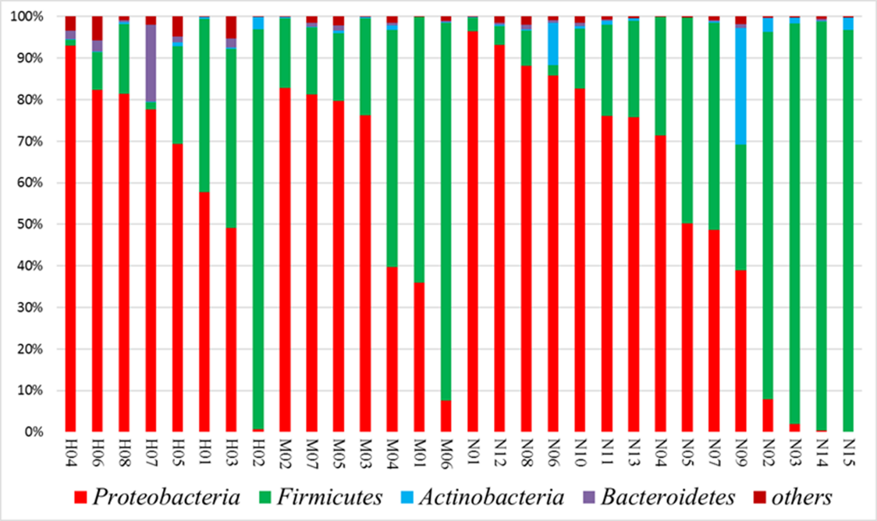
Supplementary Figure 1. Microbial communities in infants with ileostomy. The figure shows the relative abundance of the four dominant taxonomic phyla.

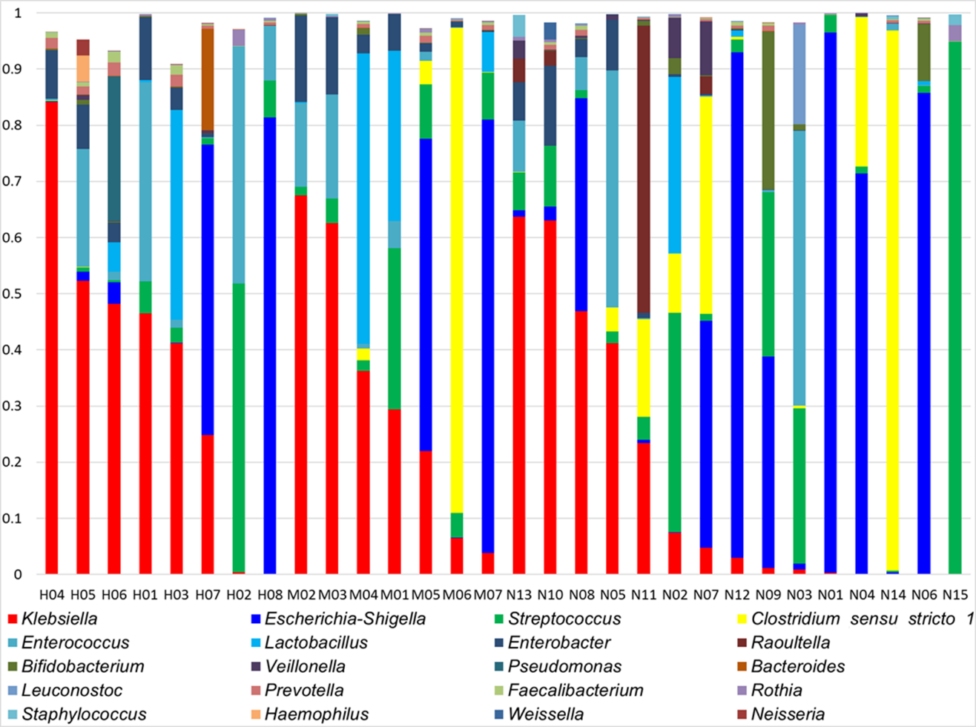
Supplementary Figure 2. Microbial communities in infants with ileostomy. The figure shows the relative abundance of the 20 taxonomic genera.

